JASMINE

**Installation of Jasmine :-**

Requires Node js

npm install -g jasmine

jasmine init

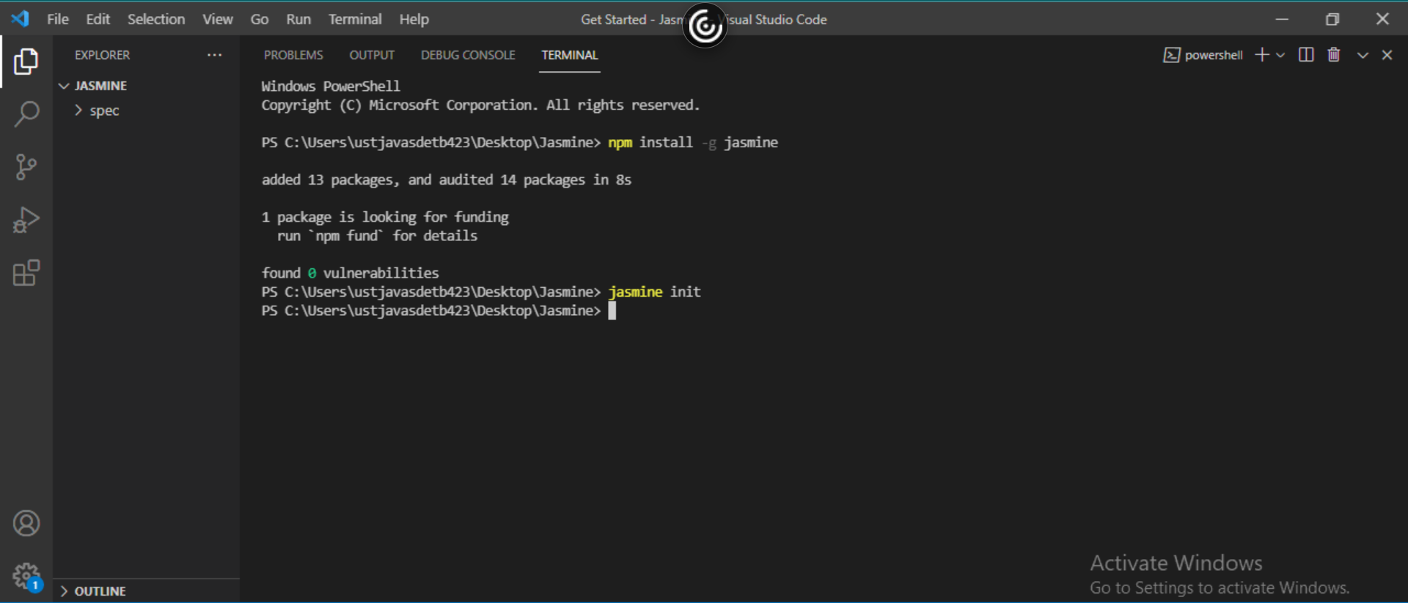

**Create a folder called Example in Spec and in that create the jasmine files**

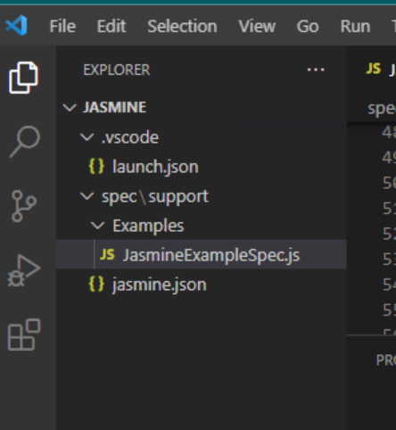

**Jasmine Example 1 :-**

const Calculator = {

    currentVal:0,

    cval:0,

    varAfterEachExmaple:0,

    add:function (num1) {

       this.currentVal += num1;

       return this.currentVal;

    },

    addAny:function () {

       var sum = this.cval;

       for(var i = 0; i < arguments.length; i++) {

          sum += arguments[i];

       }

       this.cval = sum;

       return  this.cval;

    },

 };

describe("calculator",function() {

    //test case: 1

    it("Should retain the current value of all time", function () {

       expect(Calculator.currentVal).toBeDefined();

       expect(Calculator.currentVal).toEqual(0);

    });

    //test case: 2

    it("should add numbers",function() {

       expect(Calculator.add(5)).toEqual(5);

       expect(Calculator.add(5)).toEqual(10);

    });

    //test case :3

    it("Should add any number of numbers",function () {

       expect(Calculator.addAny(1,2,3)).toEqual(6);

    });

 });

**Output :-**

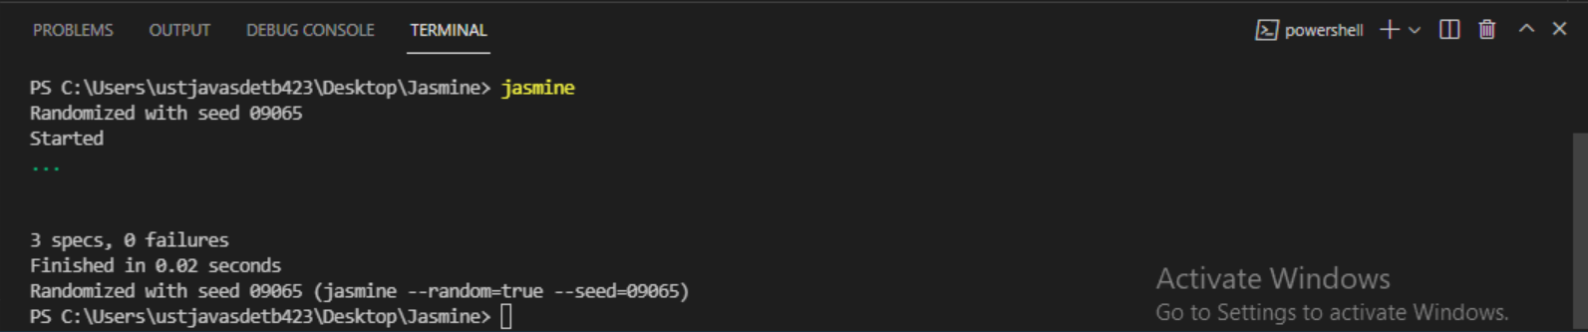

**Jasmine Example 2:-**

fdescribe('This custom matcher example', function() {

   beforeEach(function() {

      // We should add custom matched in beforeEach() function.

      jasmine.addMatchers ({

         validateAge: function() {

            return {

               compare: function(actual,expected) {

                  var result = {};

                  result.pass = (actual >= 13 && actual <= 19);

                  result.message = 'sorry u are not a teen ';

                  return result;

               }

            };

         }

      });

   });

   it('Lets see whether u are teen or not', function() {

      var myAge = 14;

      expect(myAge).validateAge();

   });

   it('Lets see whether u are teen or not ', function() {

      var yourAge = 18;

      expect(yourAge).validateAge();

   });

});

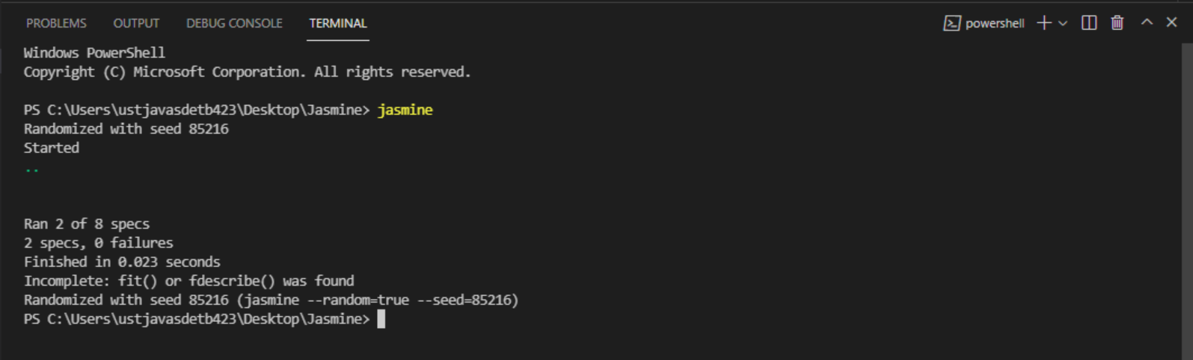

**Jasmine Example 3 :-**

var currentVal = 0;

beforeEach(function() {

   currentVal = 5;

});

fdescribe("Different Methods of Expect Block",function() {

   it("after each function ", function() {

      expect(currentVal).toEqual(5);

   });

});

**Outputs :-**

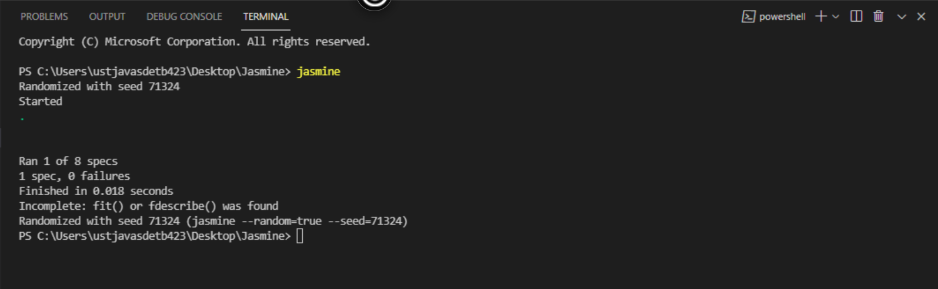

**Jasmine Example 4 :-**

var myCustomMatchers = {

  // toBeAllowedToDrive matcher

  // Usage: expect(age).toBeAllowedToDrive();

  //        expect(age).not.toBeAllowedToDrive();

  toBeAllowedToDrive: function() {

    return {

      compare: function(age) {

        var result = {};

        result.pass = age>16;

        if (result.pass) {

          result.message = "Expected " + age + " to be allowed to drive";

        } else {

          result.message = "Expected " + age + " to be allowed to drive, but it was not";

        }

        return result;

      }

    };

  }

};

fdescribe("Custom matcher: 'toBeAllowedToDrive'", function() {

  var John = 17,

    Mary = 16;

  // Custom Matchers must be added using beforeEach

  beforeEach(function() {

    jasmine.addMatchers(myCustomMatchers);

  });

  it("should allow John to drive", function() {

    expect(John).toBeAllowedToDrive();

    // replaces

    expect(John).toBeGreaterThan(16);

  });

  it("should not allow Mary to drive", function() {

    expect(Mary).not.toBeAllowedToDrive();

    // replaces

    expect(Mary).not.toBeGreaterThan(16);

  });

});

**Output :-**

